---Answers

AT: Links

UBI ≠ Inflation

UBI has no effect on prices---all relevant empirics go aff
Castells ’23 – Guillem Castells; Economist at the Pla Pilot Office to Implement the Universal Basic Income; 12-01-2023; "Guillem Castells: Universal Basic Income and inflation: What effects could it have on prices?," Ministry of the Presidency, https://presidencia.gencat.cat/en/ambits_d_actuacio/renda-basica-universal/Guillem-Castells-Universal-Basic-Income-and-inflation-What-effects-could-it-have-on-prices; //billy
The evidence
On the other hand, what can be found in the academic literature on the empirical evidence of the price effects of a UBI? A UBI as such has never been implemented anywhere, so there is no empirical information on what would happen in this case, it is an unknown. However, some papers have analysed the price effect of monetary transfers.
Cunha et al. (2019) assess the effect on prices of in-kind and cash transfers under the Programa de Apoyo Alimentario (Food Support Programme) in Mexico. Their results show how prices are reduced by in-kind transfers, as supply increases. In contrast, monetary transfers have a positive, but very small, effect on prices. The authors argue that the small effect is due to the fact that the increase in demand is offset by an increase in supply that makes the increase in prices almost negligible. They point out that the effect on prices is most relevant in the most isolated and poorest villages. This could be explained by the fact that the product markets in these villages are very closed and there is little competition between local producers, so the demand effect outweighs the effect of increased competition.
Egger et al. (2021) analysed the individual and aggregate economic impacts of a $1,000 transfer to households in rural Kenya under the NGO GiveDirectly's income transfer programme. They find statistically significant positive effects on local prices, but economically negligible at less than 1%.
Filmer et al. (2018) studied the price impact of the Pantawid Pamilya Pilipino cash transfer programme in the Philippines. They analysed price developments in locally traded perishable foodstuffs and in staple and packaged foods traded in national markets. They note that prices increase for the former, i.e., those dependent on the local market. The results are along the lines of suggesting that price effects depend on the production structure, and that in an open economy the demand effect, which would push prices up, is offset by the effect of competition, which would push prices down.
While an implementation of UBI has not happened anywhere, and therefore no evidence is available, there are some natural experiments that are slightly similar and may provide relevant information. This is the case in Alaska, where since 1982 the government has distributed a monetary amount to all citizens from the yield of an investment fund financed by the resources obtained from oil extraction (Alaska Permanent Fund Dividend). In 2021, the dividend per individual was $1,114, which, while not a basic amount for subsistence, can be significant.
No causal analysis has been conducted to observe the price impact of this dividend, although the historical inflation series for Alaska compared to the United States suggests that there have been no significant effects. The graph below shows how the evolution of the general price index for the state of Alaska in the period 1960-1982 was similar to, and always slightly below, the evolution of the price index for the country as a whole. Since 1982, when the Alaska Permanent Fund Dividend payments began, similar behaviour has been observed and the price level in Alaska has always been below the level of the index for the United States as a whole.
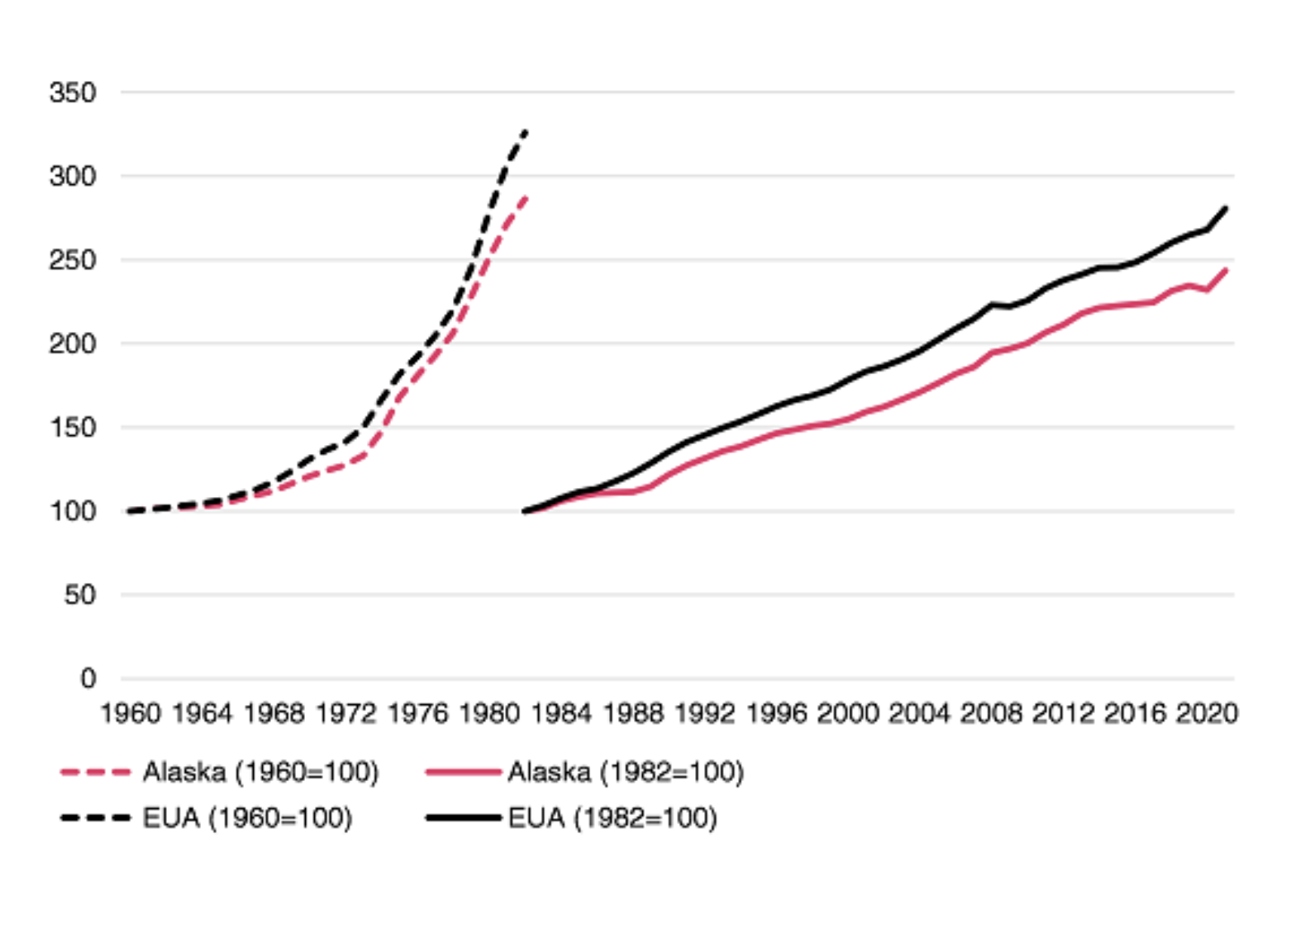
Conclusions
Overall, the limited evidence on the impact of cash transfers on prices suggests a very small, almost negligible, increase in prices. The reason is that the increase in demand is offset by an increase in supply. However, for those goods where producers have greater ability to control prices, price increases are more likely.
These results are difficult to extrapolate to a scenario in which a UBI is implemented in an economy, although they point to the idea that the impact on prices depends on the production structure. And also how they are financed: a UBI financed by taxation of higher income and wealth would be a large-scale redistribution, and the increase in the purchasing power of lower income earners can have difficult-to-foresee and far-reaching effects. The increase in demand seems clear, but what is less clear is how it would change the productive supply. If the latter is adapted to the former, prices would not increase. The time dimension is also important. Demand reacts almost instantaneously, while the production structure changes more slowly and gradually. This could generate temporary price effects.
The simple relationship according to which the increase in disposable income of a large part of the population will generate a generalised increase in prices per se, does not seem realistic.
On the other hand, and finally, it should be noted that the UBI is not an economic policy aimed at controlling and/or regulating prices. The UBI is not a panacea that solves everything: its purpose is to guarantee people's material existence. The problems caused by price increases across the board or in specific markets such as housing or energy, which are current today, would continue to exist with a UBI. They could be more or less intensified by the increase in people's income, but the structural problems that generate them would continue. Therefore, while it is necessary to contemplate the effects of a UBI on prices, one must also be clear about its purpose, and be clear that targeted tools are needed to address other issues.

Inflation link is nonsense
The Economic Times ’23 – Indian English-language business-focused daily newspaper, owned by The Times Group; 3-20-2023; "Universal Basic Income does not cause inflation," https://economictimes.indiatimes.com/news/international/world-news/universal-basic-income-does-not-cause-inflation/articleshow/98801058.cms?from=mdr; //billy
https://economictimes.indiatimes.com/news/international/world-news/universal-basic-income-does-not-cause-inflation/articleshow/98801058.cms?from=mdr
The idea that a Universal Basic Income fuels inflation makes no economic sense. We live in an age of crisis. The Global Financial Crisis, austerity measures, climate change, Covid-19 and war have all reduced people's standard of living, wellbeing and even predicted lifespan. It's a dire outlook, made worse by a fast-evolving cost of living crisis.
One way to ease the burden on people would be a Universal Basic Income.
In our last age of crisis, during WWII, Western governments took the momentous decision to tackle even more serious crises through massive state intervention. Governments rapidly committed themselves to costs with few precedents in creating social security systems, healthcare systems, nationalised industry and a range of other equality-promoting measures.
At a time in which countries could, apparently, least afford those policies, policymakers saw no alternative than to spend big. The consequence was three decades of growth, increased standards of living, increased life expectancy and unprecedented technological development, ended only by war-induced increases in energy prices that sent inflation spiralling.
As the Financial Times recently noted, the policies adopted over the past four decades have left countries such as Britain poor, but with some very rich people.
Universal Basic Income has been presented as a means of addressing this crisis.
Giving people largely unconditional, predictable forms of income to satisfy their basic needs has been identified as means of restoring social security, increasing equality and supporting growth in areas of countries that have been left behind by development and promoting public health overall.
There is, however, widespread belief that any monetary intervention stimulates hyper-inflation of the form found in 1920s Germany, 1990s Argentina and 2000s Zimbabwe.
This is because people believe that giving consumers more money to spend leads to businesses charging higher prices to take advantage of increased purchasing power, creating a cycle in which employees demand higher wages to buy commodities, increasing the cost of production, cancelling out any benefit from the monetary intervention and actually reducing the standard of living overall.
There is little evidence to support this view. UBI is no more or less inflationary than anything else that raises incomes - its impact would depend on whether the economy is at full employment, whether taxes are raised to pay for the scheme and various other factors.
Where hyperinflation has occurred, it has occurred because essential goods are scarce, raising their value overall, and debt has been held in foreign currencies and paid in currencies declining in value by virtue of countries' domestic production being disrupted or declining.
Our current levels of inflation are caused by similar pressures as those in the 1970s: war leading to an increase in the cost of fossil fuels.
If the logic behind objecting to a UBI on the basis of inflation were correct, then there ought to be absolutely no attempt to introduce new jobs or increase wages, since both increase purchasing power.
If inflation is our sole concern, governments ought to slash wages and massively increase taxes. The point is that nobody wants either of those options because, even if they did reduce inflation, people would not want to have their wages reduced.
UBI is a redistributive economic policy that can be funded by taxing those resources that contribute little to society: wealth and passive income from shares as well as income at the very top end of society.
The resources of the rich are generally off-shored and contribute little to a country's financial wellbeing.
Analysis of the distributive impacts of UBI in the UK suggest its introduction would shift resources to those people and areas that need the investment most. That may increase the cost of housing and other goods in parts of countries that have been left behind, but this is a central means of enhancing community wealth and 'Levelling Up'.
It is also a means of developing entrepreneurship and production within areas that have been de-industrialised. This support for production is, again, an essential means of supporting a bulwark against hyperinflation.
Given that we live in market societies, the fear that this will lead to unchecked inflation is counterintuitive, since competition is supported by rising purchasing power and serves to check price increases.
The alternative is simply to leave all but the metropolitan centres to wither away and to be dependent on the whims of finance.
As our recent RSA report indicated, if governments are committed to resolving our age of crisis, they need to do as their predecessors did in the wake of WWII: invest in transformative policies with expensive up front costs to achieve the most significant social outcomes. Nothing is more expensive than undoing climate change, dealing with pandemics and repairing the damage of social decay.
In that context, there is evidence a UBI is economically feasible and voters regard UBI as a necessary means of promoting social security.

AT: SS - Taxes Module

Social Security boosts the economy through redistribution, but worst case it has zero effect.
Morrissey ’19 [Monique; July 25; PhD in economics from American University; Economic Policy Institute, “Social Security expansion would likely bolster, not hurt, economic growth,” https://www.epi.org/blog/social-security-expansion-would-likely-bolster-not-hurt-economic-growth/; Sahil]
A recent analysis from the Penn Wharton Budget Model (PWBM) claims that expanding Social Security benefits along the lines of Rep. John Larson’s (D-Conn.) Social Security Act of 2100 (“the Act”) would slow economic growth. The model warrants a closer look, not just because it casts doubt on Social Security expansion, but because some of its dubious assumptions can be used against almost any policy that raises progressive taxes to pay for programs tilted in favor of low- and moderate-income Americans.
The Act, which has over 200 cosponsors, would increase payroll tax revenues to pay for expanded benefits while eliminating or greatly reducing Social Security’s long-term deficit. Among other things, the act would subject earnings above $400,000 to the Social Security payroll tax (earnings above $132,900 are not currently taxed); gradually raise the payroll tax rate; increase benefits in a progressive fashion;1 and change the consumer price index used for the cost-of-living adjustment to better match the higher inflation faced by seniors.
The PWBM projects that the Act would reduce GDP by 2 percent in 2049. According to the analysis:
“The reason for the poorer economic performance [relative to alternative reforms suggested by the PWBM that combine revenue increases with benefit cuts] is that the Act does not reduce benefits and, in fact, increases benefits by 0.61 percent of future taxable payroll by 2049. Taxes that distort economic activity are then used to reduce the actuarial balance over time, including these new benefits. The Act, therefore, actually decreases the need for higher-income households to save more for their own retirement, whereas combined reforms generally increase the need.”
In other words, increasing payroll taxes and expanding benefits reduces after-tax pay and the need for private saving, shrinking the labor supply and the funds available for investment. Since the model ignores the positive effect of progressive redistribution on aggregate demand, these negative supply-side effects slow economic growth.
A positive impact
Other economists, however, notably former Council of Economic Advisors Chair Jason Furman and former Treasury Secretary Lawrence H. Summers, view the Act as having a positive impact on economic growth, despite the need to raise taxes:
“Social Security benefits should in fact be raised for the majority of recipients. Despite the fact that Social Security is an efficient, defined benefit program, its benefits are not generous by global standards and leave too many seniors in or close to poverty. Expanding benefits only works, however, if people are willing to pay more during their working years—meaning that revenue, and not just from high-income households, has to be an important part of the solution, as in the plan advanced by Congressman John Larson. The advantage of this approach is that it would expand aggregate demand, as the additional spending by the elderly would outweigh any reductions in spending associated with higher payroll taxes, in part because the plan could lead households to save less.”
In this Keynesian view, progressive redistribution increases aggregate demand and economic growth. Though Furman and Summers approve of increasing payroll tax revenues to pay for expanded benefits, they view the tax increase as dampening the expansionary impact of redistribution from working-age households to older beneficiaries who tend to spend the money more quickly. Though Furman and Summers don’t elaborate on their reasoning, the dampening effect doesn’t primarily stem from labor market distortions, but more likely from fiscal contraction (since eliminating Social Security’s projected shortfall shrinks the unified budget deficit).
Though the negative impact of taxes on work effort looms large in the PWBM, taxes have an ambiguous effect on work effort in standard microeconomic models. Payroll and income taxes make work less appealing by reducing the opportunity cost of leisure (the “substitution effect”), but also reduce take-home pay and therefore cause the demand for leisure and other normal goods to fall (the “income effect”). While most economists estimate that the substitution effect is dominant, the net effect on the labor supply may be quite small because of the offsetting income effect.
The PWBM, however, assumes that labor supply is very sensitive to tax increases. Thus, while a Congressional Budget Office (CBO) review of the literature found that the Frisch labor supply elasticity, which measures the responsiveness of labor supply to tax increases, ranged from 0.27 to 0.53, the PWBM assumes a Frisch elasticity of 0.5, close to CBO’s upper-bound estimate.
This appears to be a pattern with the PWBM, where important parameters fall within the range of respectable opinion but are tilted in the direction of finding negative effects of tax increases and budget deficits. In addition to a high labor supply elasticity, the PWBM assumes that the saving rate is highly sensitive to after-tax investment returns, and that investment, in turn, is highly dependent on domestic saving despite international capital flows. With assumptions that exaggerate the negative effects of taxes and deficits, spending cuts are left as the surefire way to boost economic growth, in line with the apparent preferences of some of PWBM’s funders, such as former Microsoft CEO Steve Ballmer.
Generally speaking, policies that increase saving will, all else equal, tend to boost growth in supply-side models, while those that tend to reduce saving—including expanding Social Security benefits—will have the opposite effect. Social Security reduces private saving because people would save more in its absence, though not enough to offset the loss of benefits. Social Security itself functions mostly as a pay-as-you-go program, with payroll taxes from workers going directly to retirees and other beneficiaries.2 The net effect of expanding a program that has little direct effect on government saving but indirectly reduces private saving is a reduction in national saving. However, since the Act raises taxes not only to expand benefits but also to close the projected shortfall, it is not at all clear that it reduces national saving relative to CBO baseline projections.
In addition, since wealthy people tend to save a greater share of their incomes and savings is assumed to drive investment in supply-side models, upward redistribution generally translates into greater investment and faster growth in supply-side models. The PWBM, for example, projects faster growth in the near term from the Trump tax cuts due to increased private saving and investment.3 In Keynesian models, on the other hand, regressive redistribution tends to decrease aggregate demand because high-income households tend to save more. Conversely, progressive redistribution, as in the Act, boosts economic growth except when the economy is already operating at full employment, which is likely to be the exception, not the rule.
Whether you believe the PWBM analysis or Furman and Summers depends on whether you think economic growth is, as a rule, demand- or supply-constrained. Many economists split the difference, viewing Keynesian models as “short-term” and supply-side models as “long-term.” This gives the latter, which are often based on theory rather than grounded in reality, more weight in policy discussions than they deserve, especially since the full employment assumption is rarely spelled out.4
Whereas Keynesians often take into account some supply-side effects, the reverse is generally not true of supply-side models, which preemptively rule out demand-side effects on employment and economic growth by assuming that the economy is operating at capacity in the long-run. In these models, the growth rate depends only on the size and productivity of the workforce, the level of investment, the return on capital, and perhaps technological change. Thus, the only effect on employment derives from more people choosing to enter the labor force or work more hours, often in response to tax cuts. But as John Maynard Keynes famously quipped about assuming that unemployment and underemployment can only be temporary deviations from the full-employment norm, “In the long run, we’re all dead.”

AT: Impact

Econ Resilient

Economy is resilient
AFP 6/30/23 (Agence France-Presse is a French international news agency headquartered in Paris, France. Founded in 1835 as Havas, it is the world's oldest news agency. “US Economy 'More Resilient' Than Expected: Yellen” https://www.barrons.com/news/us-economy-more-resilient-than-expected-yellen-f58950bf)]//ca
The US economy "has proven more resilient" than anticipated despite recession forecasts, Treasury Secretary Janet Yellen is due to say Friday, expressing hope the country can lower inflation while maintaining labor market strength. Her comments come shortly after revised economic data showed the world's biggest economy expanded significantly more than estimated in the first quarter, supported by consumer spending. Meanwhile, inflation has been cooling on an annual basis. "I continue to believe that there is a path to reducing inflation while maintaining a healthy labor market," Yellen said, in prepared remarks to be delivered at an event in New Orleans. "Without downplaying the significant risks ahead, the evidence that we've seen so far suggests that we are on that path," she added. Business leaders have also "increasingly voiced confidence" in the US economy, according to her remarks. Labor market strength and strong household and business balance sheets, she added, should help support the economy going forward even if activity eases as inflation comes down. "While there are parts of our economy that are slowing down, households are spending at a robust pace and businesses continue to invest," Yellen said. With data signaling the US economy has been stronger than expected, analysts said some are now questioning if a recession is inevitable for the country or if a "soft landing" is possible. This refers to a scenario where inflation comes back down to policymakers' two percent target without a major downturn. In her prepared speech, Yellen also lauded the achievements of President Joe Biden's administration, including efforts to boost infrastructure investment and the country's semiconductor sector. The president's agenda, dubbed Bidenomics, comes as he seeks re-election in 2024.

